Women’s Association of Memorial University of Newfoundland
Annual General Meeting
Saturday, October 30th, 2021
(Postponed from Saturday, September 11th, 2021)
Fluvarium, Pippy Park, St. John’s
Minutes

- The President called the meeting to order at 2:30 pm. A list of attendees appears at the end of these minutes.

- Approval of the Agenda – moved by K. Matthews; seconded by B. Gardner; all in favour.

- Approval of the Minutes of the AGM on October 22nd, 2020 – moved by J. Mathieson, seconded by O. Bloomfield-Richards with the addition of K. Herzberg’s name to the list of attendees; all in favour.

- Business Arising – None.

- Reports
- President’s Report (K. Simonsen reporting): WAMUN held fewer activities this year because of COVID. Our scholarship fund as surpassed $200,000 and is now self-sustaining. WAMUN now needs to consider that action, if any, is to be taken to adjust the present terms of the scholarships. She thanked the Social Convenors and the rest of the Executive for their contributions and invited the membership to consider running for the Board.
- Membership Report (J. Mathieson reporting): WAMUN had 66 paid-up members in 2020-2021.
- Treasurer’s Report (J. Hiller reporting): WAMUN had a balance of $3486 on August 31st, 2020. WAMUN donated $1500 to the Student Emergency Fund this year. The balance as of August 31st, 2021 was $3011. The treasurer will arrange for members to pay their dues by e-transfer for the 2021-2022 membership year.
- Newsletter Report (D. Milne, absent): The latest issue was published on October 29th with very positive feedback so far.
- Scholarship Committee Report (D. Rehner reporting): The Committee members are Dorothy Milne, Ann Noseworthy and Deborah Rehner. D. Rehner read out the report written by D. Milne (see attached).
A broad discussion of possible changes ensued including the following points:
- The present amounts of the scholarships
- The amount by which the fund is depleted annually
- Whether Grenfell students were eligible for both undergraduate and graduate awards
- Increasing the value of each award
- Setting up a bursary versus another scholarship
- Developing and expanded ad hoc committee to review our scholarship mandate
- Consulting the appropriate University staff for advice
The Scholarship Committee agreed to explore all these issues and invited any interested members to join the process. A report should be available before the next AGM, scheduled for April 2022.

- Reports from Interest Group Convenors
- Karen Herzberg reported on E-Toys and Snap and Chat.
- Zoom Café is a good medium for both local and “away” members to communicate.
- Beverly Gardner reported that the Coffee Group plans to meet the second Wednesday of each month until June 2022.
- Marjorie Evans and Deborah Rehner reported on the two Walking Groups.
- Mary Chalker reported that the Zoom Non-fiction Book Club has an international member; Miriam Simpson sent an email report on the Fiction Book Club.

- Election of Officers for 2021-2022
The chair of the meeting was assumed by Marjorie Evans. She presented a full slate of nominees (see attached). No further nominates were forthcoming. The slate was adopted. Dorothy Milne was commended by the membership for her extensive contributions to the association.

- Other Business
K. Matthews promoted the upcoming Scrabble event organized by the Terra Nova Grannies on Nov. 13th at the Lantern. She thanked WAMUN members for their support of the Grannies’ Walk in June 2021, which raised $5400.
Members then sang “Happy Birthday” to H. Shinkle and G. Bahturina.

- Adjournment – moved by J. Hiller.

The meeting was adjourned at 3:42 pm.

Minutes respectfully submitted by F. O’Neill.

List of attendees

Galina Bahturina
Olga Broomfield-Richards
Brenda Burness
Mary Chalker
Marjorie Evans
Beverly Gardner
Daphne Gillingham
Karen Herzberg
Joan Hiller
Marguerite Jones
Donna Kelland
Karen Lippold
Julia Mathieson
Kay Matthews
Elke Molgaard
Frankie O’Neill
Ingrid Pardoe
Dorothy Parker
Uta Passow
Deborah Rehner
Suzanne Sexty
Hatty Shinkle
Kathy Simonsen
Mary Watson
Pat West
Betty Wong

REPORT OF THE SCHOLARSHIP COMMITTEE
WAMUN AGM
The Fluvarium
September 11, 2021

Despite some minor processing delays caused by the COVID-19 epidemic, the funding, awarding and reporting of the WAMUN scholarships were carried out successfully during the 2020-2021 academic year.

1. Donations received from WAMUN members in the Fall of 2020 totalled $2,120. This is close to the average for recent years. The scholarship committee hopes and recommends that donations by members continue at this rate in order to secure the future of our scholarships.

2. Four undergraduate and four graduate student scholarships worth $1,200 were awarded:

Undergraduates:
Marisa Pinksen Mature student
Amie Richards Single parent
Hannah Murphy Faculty/Staff
Daniel Burke Undergraduate

Graduates:
Hayley Paquette Ph.D. Lichen taxonomy and biogeography
Roshni Kollipara Ph.D Cannabinoid therapy for epilepsy
Melissa Pike Masters (non thesis) Sociology of time re. women’s lives
Rogin Tharle-Oluk Masters (thesis) Concussion recognition in sports

3. The closing balance of the WAMUN Scholarship Endowment Fund increased from $196,133 on March 31, 2020 to $201,167 on March 31, 2021. A copy of the endowment fund report is shown on the next page.

4. The investment income on the endowment fund in 2020-2021 was $9,114. It is most encouraging to note that in each of the past five years this amount has exceeded the $7,200 needed annually to fund the eight scholarships.

5. In light of the recent doubling of tuition fees at Memorial, it may be time for WAMUN to consider how it might increase its financial support to students.

The Endowment Report

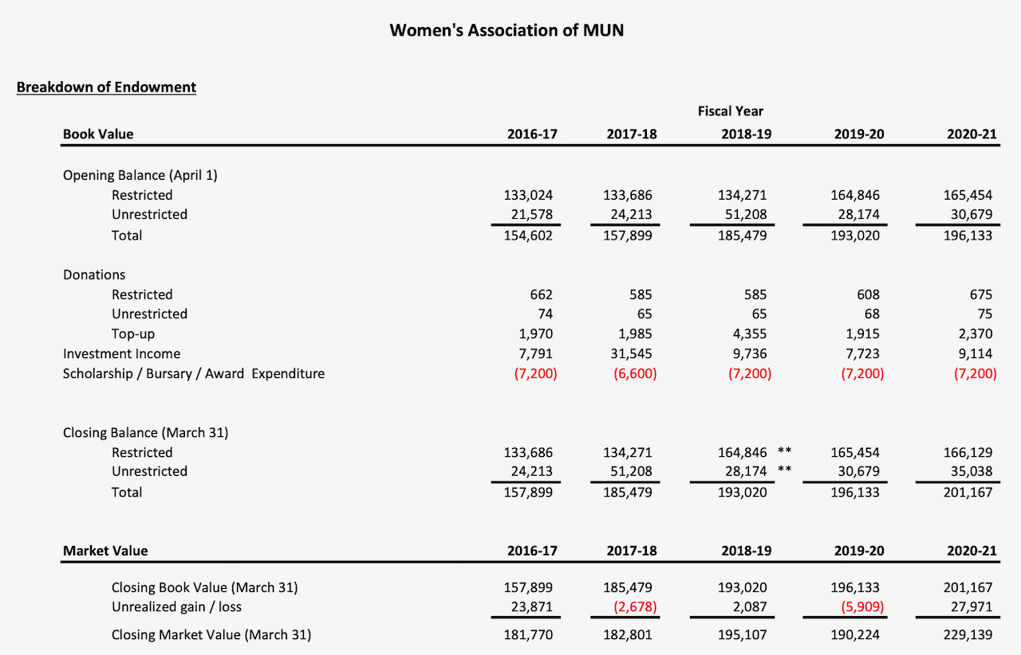

Report submitted by the Scholarship Committee: Dorothy Milne (chair), Deborah Rehner, and Ann Noseworthy

WAMUN AGM
October 30th, 2021
List of Candidates for the Executive 2021-2022

Position Candidate

President Kathy Simonsen
Vice-President Ann Noseworthy
Treasurer Joan Hiller
Secretary Frankie O’Neill
Membership Secretary Julia Mathieson
Newsletter Editor Dorothy Milne
Social Conveners Brenda Burness, Karen Lippold, Ingrid Pardoe
Nominations from the floor are welcome!

