SAMPLE PANEL VISIT ITINERARY
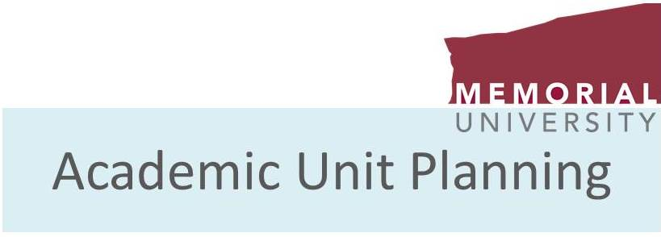

[Unit Name/Program]
Site Visit Itinerary – [Date]

Thursday, [Date]  Room: |  | Friday, [Date]  Room: |  | Saturday  [Date]
9:00 AM | Welcome Breakfast – Panel members meet with Associate VP(Academic), Dean of Record, Dean of Grad Studies, AUP Coordinator | 9:00 AM | Organizational Meeting:  Panel & AUP Coordinator | Panel:  Draft  Report  Room:
9:30 AM |  | 9:30 AM | Unit Head
10:00 AM | Organizational Meeting:  Panel & AUP Coordinator | 10:00 AM | [Unit to determine]
10:30 AM | Unit Head  Tour of Facilities | 10:30 AM | [Unit to determine]
11:00 AM | [Unit to determine] | 11:00 AM | [Unit to determine]
11:30 AM | [Unit to determine] | 11:30 AM | [Unit to determine]
12:00 PM | Panel Lunch with  Unit Head and 2 Guests | 12:00 PM | Panel Working Lunch
12:30 PM |  | 12:30 PM
1:00 PM |  | 1:00 PM
1:30 PM | [Unit to determine] | 1:30 PM | [Unit to determine]
2:00 PM | [Unit to determine] | 2:00 PM | [Unit to determine]
2:30 PM | [Unit to determine] | 2:30 PM | [Unit to determine]
3:00 PM | [Unit to determine] | 3:00 PM | Panel confers for exit meetings
3:30 PM | Coffee Break | 3:30 PM | Exit Meeting with Dean of Record  (Panel shares preliminary findings)
4:00 PM | [Unit to determine] | 4:00 PM | Exit Meeting with Unit Head  (Panel shares preliminary findings)
4:30 PM | [Unit to determine] | 4:30 PM | Exit Meeting with Unit Head, Faculty, Students, Staff  (Panel shares preliminary findings)
5:00 PM | Suggested time for panel to confer | 5:00 PM | Suggested time for panel to confer
7:00 PM | Working supper for panel to discuss meetings and report writing | 7:00 PM | Working supper for panel to  discuss meetings and report writing
Typical Items Included in the Site Visit Schedule
Site Visits are normally held on a Thursday and Friday.
- An initial meeting AVPA, Dean of Record, and the review panel usually takes place on Thursday morning.
- An organizational meeting takes place with the review panel and AUP coordinator at the start of each morning.
- On both Thursday and Friday the first unit meeting is usually with the Unit Head (morning coffee).
- On Thursday there is a panel lunch with the four reviewers, the Unit Head, and two guests
- If applicable, a tour of facilities is included on the first day.
- Interviews normally take place with the following people, although other individuals/groups who are identified can also be included:
- Faculty members - individually or in groups
- Students - undergraduate and graduate
- Staff
- Alumni
- Dean/Associate Dean
- Dean of Graduate Studies
- Others, as determined by the unit
- Writing time is provided for the panel on Thursday and Friday either before or after the supper break, and at times throughout the day if the schedule allows.
- The last scheduled meetings are exit interviews (last thing Friday afternoon) with the panel, Dean of Record, Unit Head, and members of the Unit.
- The panel is usually given time before the exit interviews for a meeting to confer.
- The panel has time on Saturday for report writing (usually goes until lunchtime).

