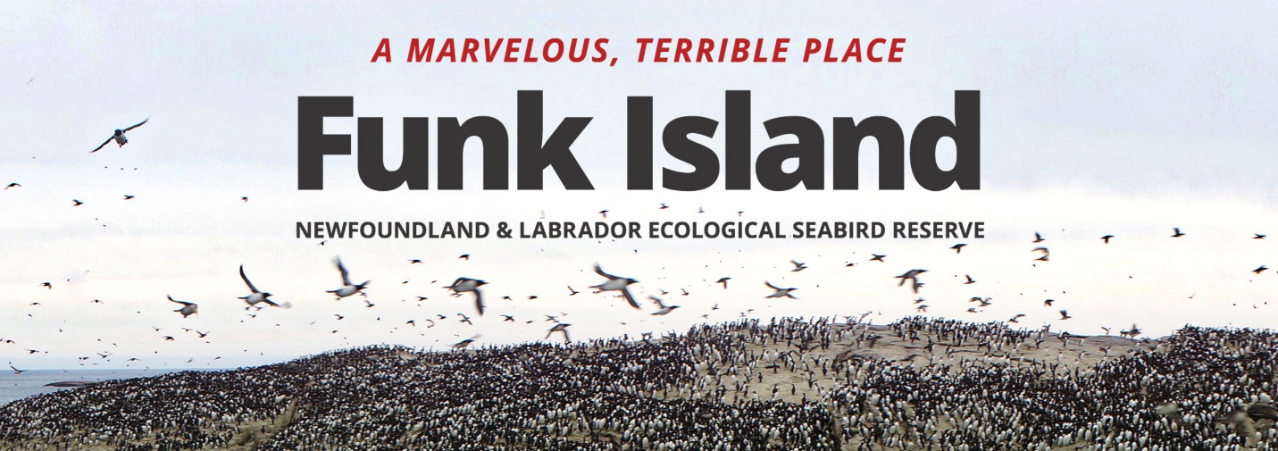
Ever wonder what it would be like to study seabirds on an isolated seabird island?
At 730 PM on Thursday November 22nd in Room A-1046 in the Arts Building Atrium at Memorial University, join filmmaker Nigel Markham and Memorial University seabird scientist Bill Montevecchi for the launch of the youtube website – “A Marvelous Terrible Place”.
Funk Island, a small ocean rock outcrop, is the most spectacular and remote seabird breeding site in the North Atlantic. Located 40 km off the NE Newfoundland coast, it is home to massive colonies of murres and gannets.
In 1501, the first Portuguese explorers referred to Funk as Y dos Aves or Island of Birds and prior to European arrival the Beothuk knew it as the sacred island over the horizon.
Once the home of the last flightless bird of the Northern Hemisphere – the Great Auk, the island became a focal site of over-exploitation, where birds were slaughtered for feathers and bait. By 1800, the Auks were gone and soon the island was a barren rock.
Seabirds began returning to Funk Island in the 1900s and later in the century the colony gained protection as a provincial Ecological Reserve.
Today – Funk Island is a source of seabird resilience and productivity where murres, gannets, razorbills, puffins, fulmars, kittiwakes and gulls congregate to mate and rear their young.
Contacts = Nigel Markham (n.markham@nf.sympatico.ca)
Bill Montevecchi (mont@mun.ca)

