# **Book Launch**

# Join the Department of Folklore in a celebration of the scholarship of former colleague David Buchan (1939-1994) with the launch of The Ballad and the Folklorist: The Collected Papers of David Buchan

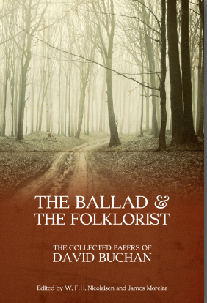

Tuesday, March 25, 2014

**7:00 p.m.-9:00 p.m**.

**Bitters Pub and Restaurant**

Field Hall, 216 Prince Philip Drive, St. John’s, NL A1B 3R5